20th April 2023
RE: UPDATED INDUSTRIAL ACTION
Dear Parents / Guardians
The main teaching unions are due to hold a full day of strike action on Wednesday 26th April 2023. St Teresa’s will not be open to receive any pupils on that day.
Once again the decision to close the school is based on health & safety reasons given that we will not have the teaching personnel to provide adequate teaching or supervision throughout the day.
Thank you for your continued support and cooperation.

Yours sincerely,
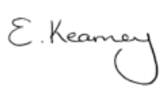
E Kearney (Mr)
Principal

