New School Website
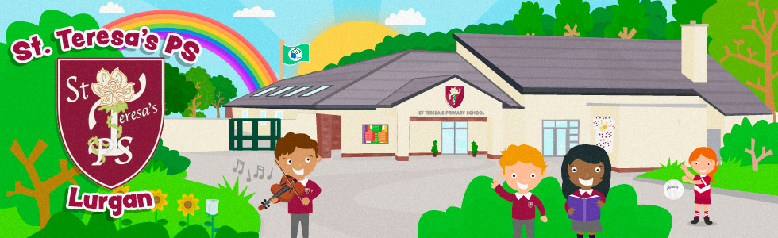
To launch our new website www.stteresaslurgan.com we are running a competition, have a look through the new website and try to find the answers to the following questions:
- Who was the special visitor to P2, what was his job? _________________________________________________
- What class will do ‘Flight’ as a World Around Us topic? __________________________________________________
- What school did our gaelic team (P6/7) play last? __________________________________________________
- Which class recently visited Croke Park? __________________________________________________
- On which page would you find links to literacy and numeracy websites to help you with your homework?
__________________________________________________

Please complete answers and place completed form into the box in your classroom by Friday 11th March.

Name: ______________________________________

Class: ____________

